***Process on Help***

*Go to tcode se61Enter details given below.Click on create.*

*DOCUMENT CLASS – GENERAL TEXT*

*IT IS IMPORTANT*

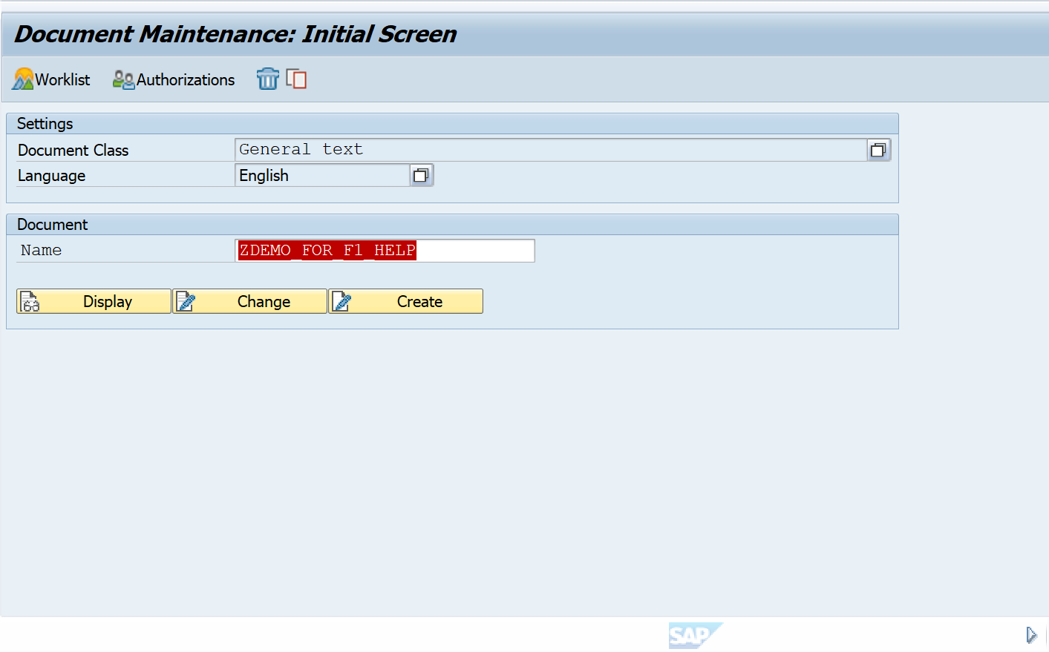

*Enter the help statement Eg.* ***Simple help***

*Activate it*

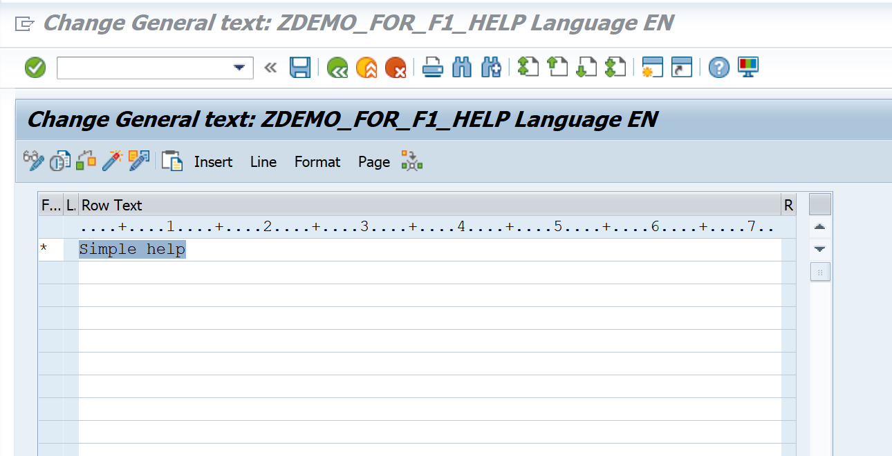

Go to Se80 .

Design a screen 100 as shown below.

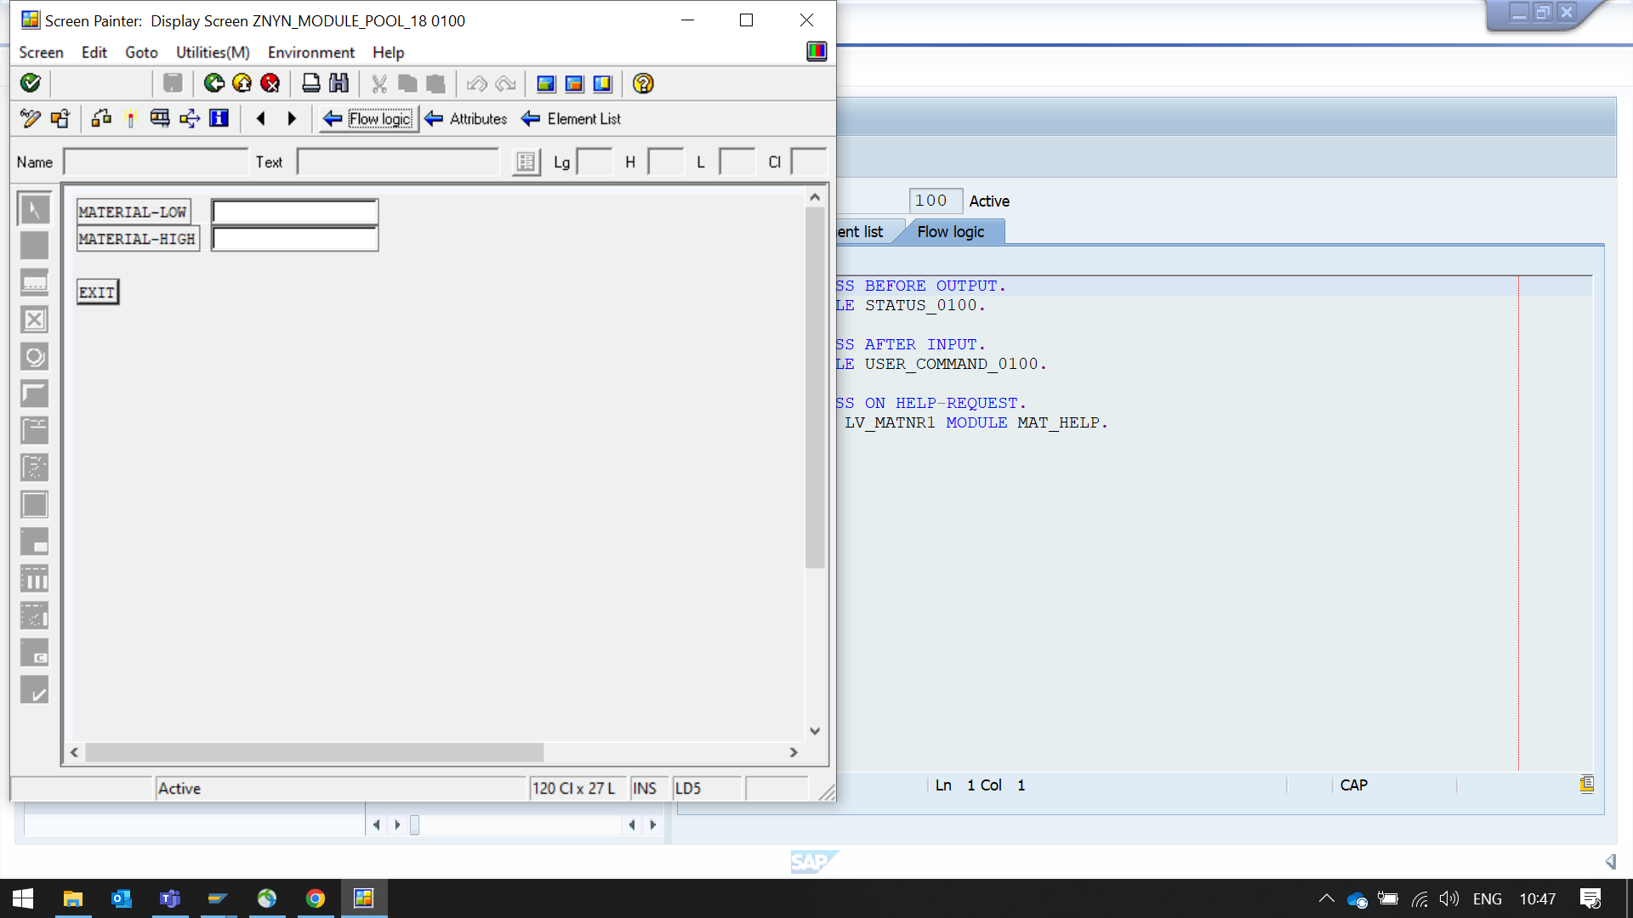

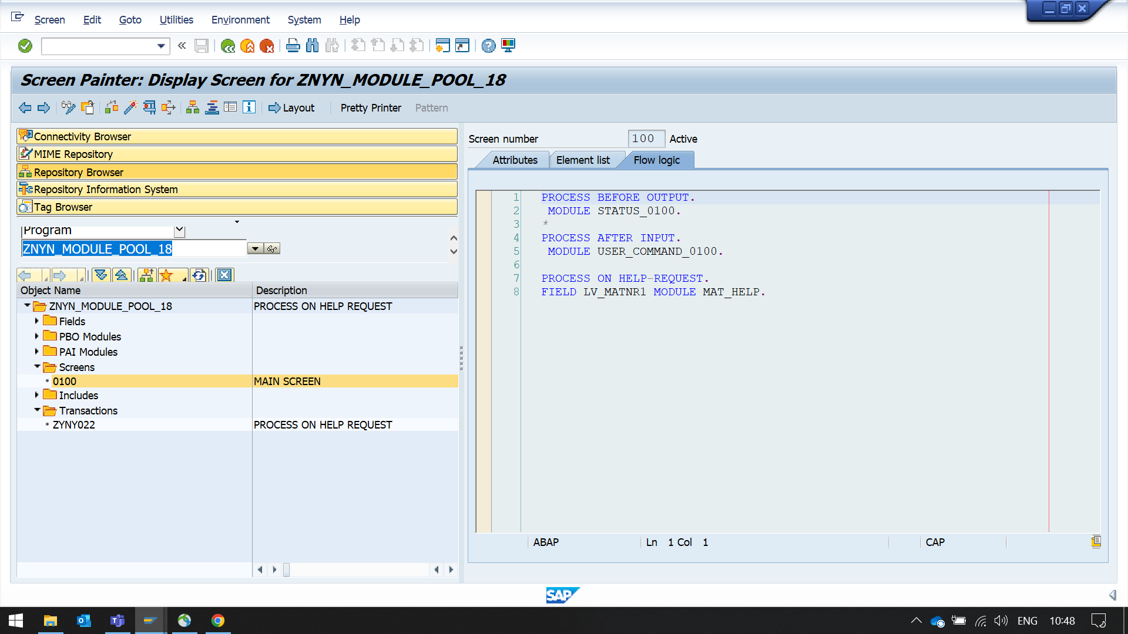

*Add the below code in the respective modules.*

*&---------------------------------------------------------------------*  
*& Report  ZMPOOL_F1  
*&  
*&---------------------------------------------------------------------*  
*&  
*&  
*&---------------------------------------------------------------------*  
REPORT ZMPOOL_F1.  
DATA LINKS TYPE TABLE OF TLINE.  
DATA: LV_MATNR1 TYPE MARA-MATNR,  
      LV_MATNR2 TYPE MARA-MATNR.  
*&---------------------------------------------------------------------*  
*&      Module  STATUS_0100  OUTPUT  
*&---------------------------------------------------------------------*  
*       text  
*----------------------------------------------------------------------*  
MODULE STATUS_0100 OUTPUT.  
  SET PF-STATUS SPACE.  
*  SET TITLEBAR 'xxx'.  
ENDMODULE.  
*&---------------------------------------------------------------------*  
*&      Module  USER_COMMAND_0100  INPUT  
*&---------------------------------------------------------------------*  
*       text  
*----------------------------------------------------------------------*  
MODULE USER_COMMAND_0100 INPUT.  
  CASE SY-UCOMM.  
    WHEN 'EXIT'.  
      LEAVE PROGRAM .  
  ENDCASE.  
ENDMODULE.  
  
*&---------------------------------------------------------------------*  
*&     MODULE MAT_HELP INPUT.  
*&---------------------------------------------------------------------*  
*       text  
*----------------------------------------------------------------------*  
MODULE MAT_HELP INPUT.  
  
  CALL FUNCTION 'HELP_OBJECT_SHOW'  
    EXPORTING  
      DOKCLASS         = 'TX'  
      DOKLANGU         = SY-LANGU  
      DOKNAME          = 'ZNYN_FOR_F1_HELP'  
*                              /Give  the name from  tcode se61  
      CALLED_FOR_FIELD = 'LV_MATNR1'  
    TABLES  
      LINKS            = LINKS  
 EXCEPTIONS  
     OBJECT_NOT_FOUND = 1  
     SAPSCRIPT_ERROR  = 2  
     OTHERS           = 3  
    .  
  IF SY-SUBRC <> 0.  
* Implement suitable error handling here  
  ENDIF.  
ENDMODULE.

*Add a TCode to the Mpool program.*

*Execute the Tcode. Screen is displayed.*

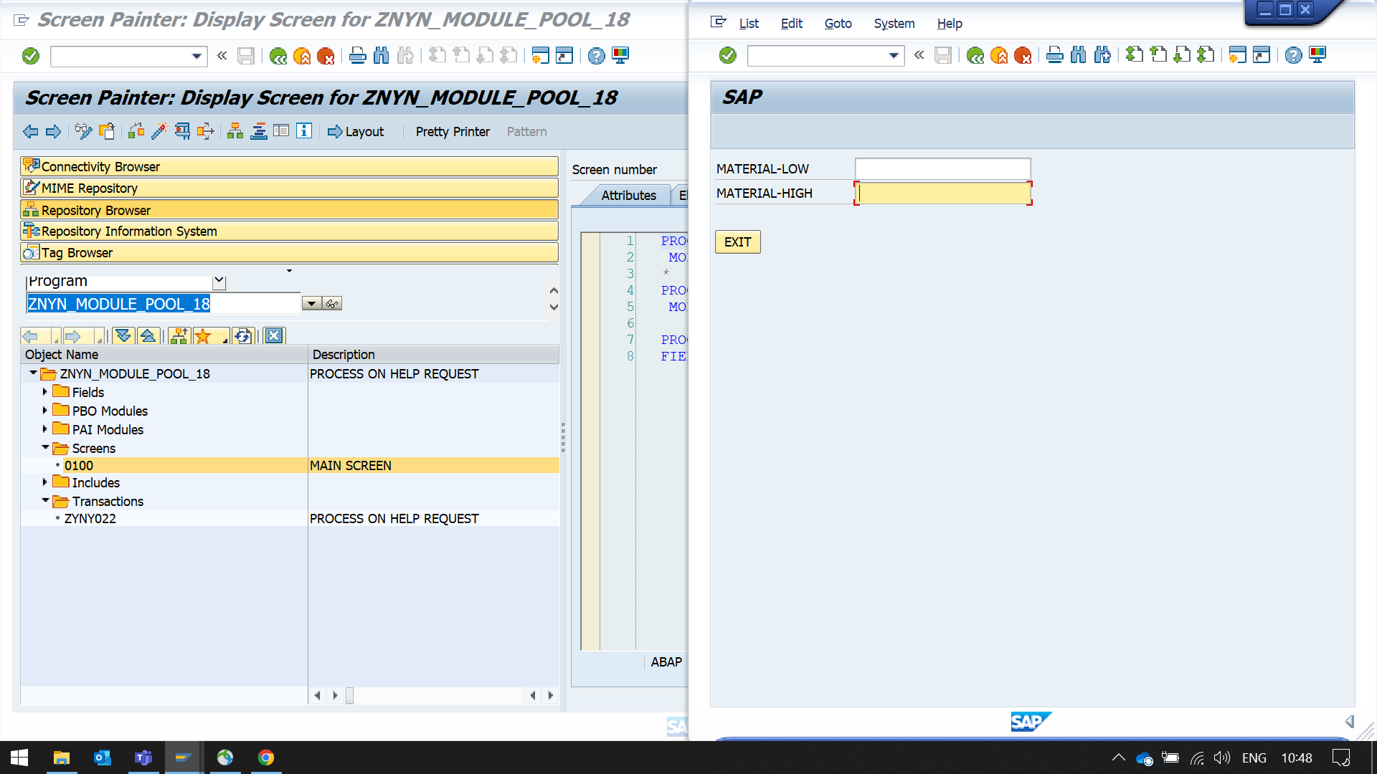

*Click on F1 on the i/p field lv_matnr1.You will notice that the Help message is displayed.*

